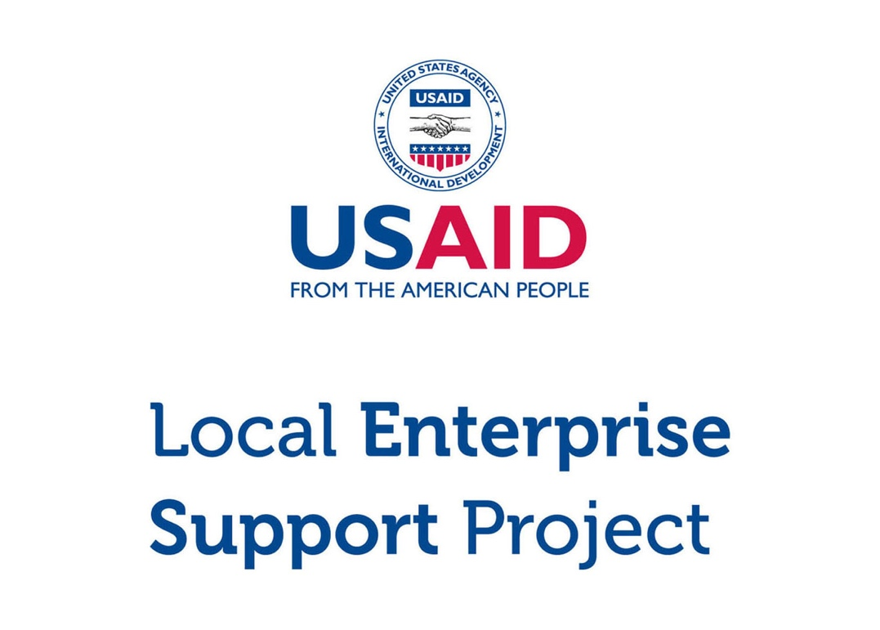

**Micro and Small Enterprise (MSE) Survey**

Results for Zarqa Governorate

Tuesday, March 15, 2016 (version 2)

**Highlights**

|  |  |  |
| --- | --- | --- |
| 15,733  MSEs |  | MSES ARE THE MAJORITY > There are an estimated 15,733 micro and small enterprises in Zarqa. Roughly half of all MSEs are single-person businesses, and just under half operate in retail and trade. |
|  |  |  |
| 9.5%  WOMEN |  | MSES ARE MALE-DOMINATED > Only 9.5% of Zarqa’s MSEs are female-owned. Women who have MSEs are more likely than men to earn less, to operate out of home locations, and to work out of necessity. |
|  |  |  |
| 3/4  REGISTER |  | MSES EXIST ON PAPER > Despite the fact that most MSEs do not pay tax and only half have employees, three in four are nonetheless registered with the Ministry of Industry and Trade. |
|  |  |  |
| 5 YEARS  IN EXISTENCE |  | MSES ARE NACENT > The typical MSE has been in business for five years. Four in five businesses in Zarqa believe they will continue to operate for at least 3 years. |
|  |  |  |
| 300 JOD  PROFIT |  | MSES STRUGGLE TO GET BY > MSEs that make profit report a median bottom line of 300 JOD per month (usually excluding the MSE owner’s own salary). 66.6% of MSEs are losing money or struggling to live comfortably. |
|  |  |  |
| 16% USE  COMPUTERS |  | MSES ARE DIGITALLY ABSENT > Only 16% of businesses use a computer in the course of their work. Less than one in five uses social media either for work or personal purposes. |
|  |  |  |
| <5%  PENETRATION |  | MSES LACK COLLECTIVE POWER > Membership in associations are weak. With this exception of the chambers, the penetration rate for trade associations, business groups, and cooperatives is below 5%. |
|  |  |  |

Table of Contents

Introduction 3

General Demographics 5

Contracts 17

Workforce 18

Firm Performance 21

Access to Finance 24

Systems, Processes and Networks 26

Policy and Regulations 28

Data was compiled using data file “**new_lens_usa_fix_pswt.sav**” (MD5 hash: 3958a9180d)

# Introduction

## About USAID LENS

The USAID Jordan Local Enterprise Support Project (LENS) is a five-year project to encourage the long-term economic growth and development potential of underserved Jordanian communities. USAID LENS combines local economic development with private sector development initiatives to help create jobs and sustainable growth that is inclusive of women and youth.

LENS’ systemic approach to local economic development is meant to catalyze inclusive local and regional economic networks in a business-enabling environment, while developing the competitiveness, sustainability and growth of micro and small enterprises.

## About the Survey

Although Jordan’s economy is dominated by micro and small enterprises (MSEs).[1] relatively little is known about them. To overcome this informational gap, USAID LENS conducted a survey of MSEs in 2014-2015 to better understand Jordanian enterprises and to assess the major barriers and opportunities for growth. The study covers general demographics, workforce trends, firm performance, access to finance, processes and networks, and the impact of the Syrian refugee crisis.

The survey consists of 86 questions in a double sampling design with stratification. The data gathers representative information for all MSEs operating in the governorates of Amman, Zarqa, Irbid, Karak, Tafilah, and Aqaba.[2] Although the study is not intended to be national in scope, the target population of the six areas collectively capture 60% of the kingdom’s population.

As a complex survey, the research design was undertaken using probability sampling in two phases. In the first phase, 977 geographic clusters were randomly selected from districts in each area. From these clusters, 97,347 households were contacted through door-to-door interviews, of which 10,197 reported owning a business. A sub-sample of 6,385 MSEs was then drawn, stratified by sector and governorate. 4,721 of these MSEs were then successfully surveyed (495 in Zarqa).

This report focuses exclusively on results from the governorate of Amman. Findings are taken from USAID LENS’ MSE survey, and can reliably be generalized to all MSEs within this geographic boundary.[3]

# General Demographics

## Firm Characteristics

Based on the survey research, there are an estimated 15,733 MSE owners in Zarqa governorate.[4] An overwhelming majority of these are owned by men (90.5%).

The proportion of male to female businesses is generally consistent with government figures. According to the Department of Statistics (DOS), women account for only 13.0% of the Jordanian labor force nation-wide. According to the survey, only 12.5% of businesses in Zarqa either employs women or is managed by one.

|  |  |  |  |  |  |
| --- | --- | --- | --- | --- | --- |
| **Demographics (Zarqa)** |  | **Sample** |  | **Population Estimate**[5] | |
|  |  | *n* = 495 |  | *N* = 15,733 | % of group |
| **By Select Sector**[6] |  |  |  |  |  |
| Food Processing |  | 61 |  | 2,073 | 13.2% |
| Tourism |  | 49 |  | 1,486 | 9.4% |
| Transport |  | 32 |  | 1,236 | 7.9% |
| ICT |  | 30 |  | 466 | 3.0% |
| Other |  | 323 |  | 10,474 | 66.6% |
| **By Sex of the Owner** |  |  |  |  |  |
| Male |  | 451 |  | 14,236 | 90.5% |
| Female |  | 44 |  | 1,497 | 9.5% |

Food Processing accounts for the largest of the four sectors above, representing 13.2% of all MSEs in Zarqa. Tourism follows with 9.4%, Transport with 7.9%, and ICT with 3.0%. MSEs outside of these target sectors account for the remaining 66.6%. ‘Other’ business types include mainly manufacturing of apparel, structural metal products, furniture in addition to retail trade, medical and dental activities, repair of personal and household goods and other personal service activities.

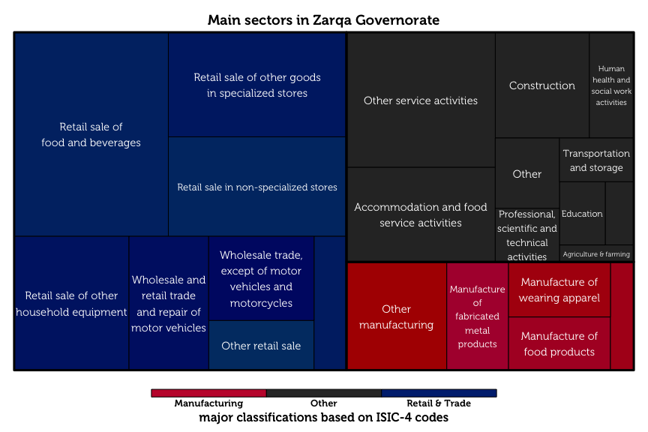

The treemap diagram above shows the relative sizes of each business category, as classified by ISIC-4 codes.

## Respondent Characteristics

The typical MSE owner in Zarqa is a married, 40-year old male with secondary school as his highest level of education. Over two thirds of these owners have families of moderate size (4 – 7 members). Male business owners are typically the primary earners of their household, in sharp contrast to female MSE-owners, who are rarely the breadwinners for their families.

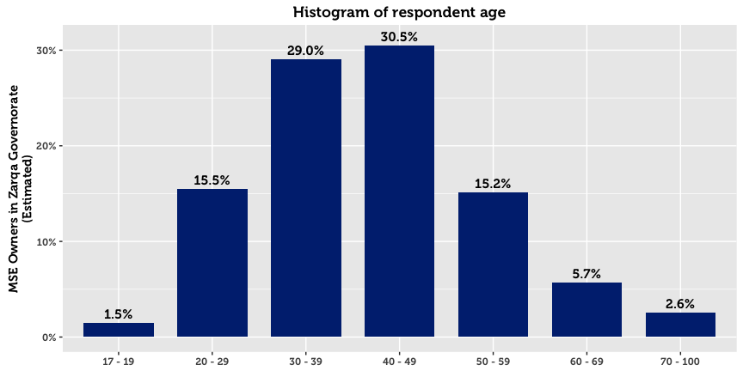

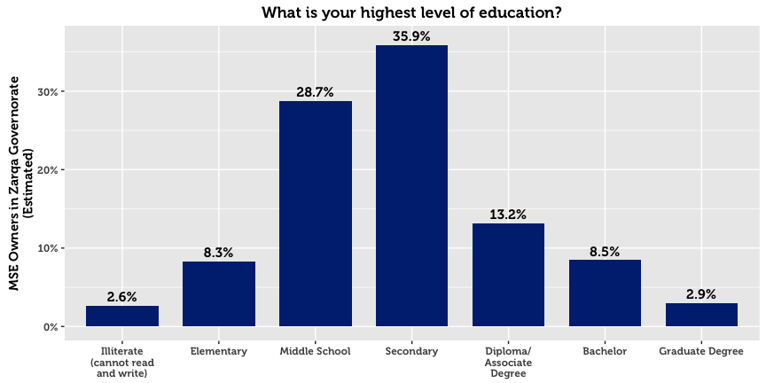

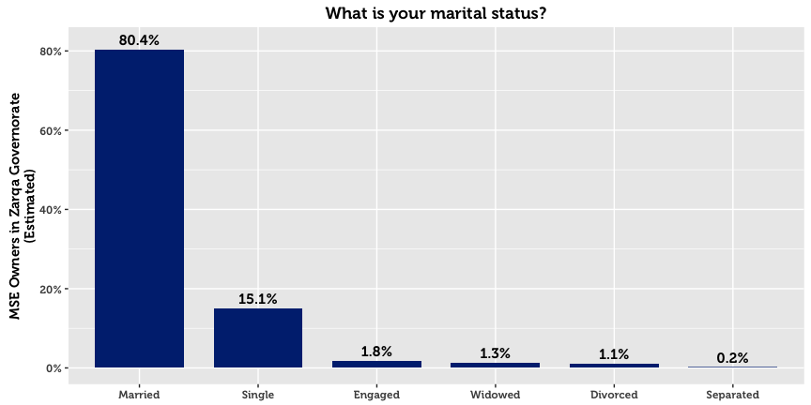

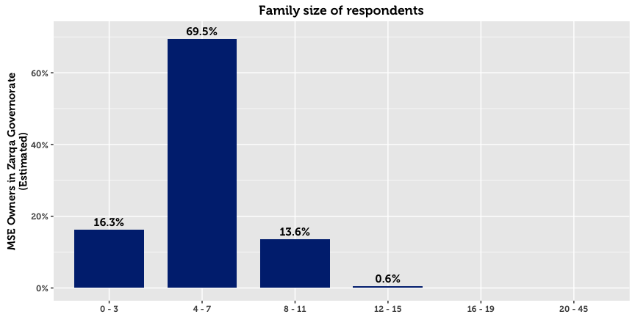

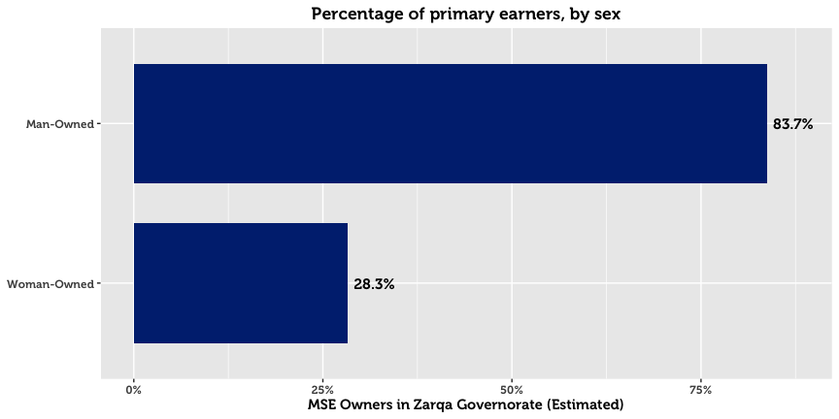

## Establishment, Registration & Business Continuity

The survey reveals that roughly half of the MSEs in Zarqa in existence today were established in the last seven years. Going back further, 75% of MSEs registered after 2000. Four in five of all MSEs in Zarqa believe that they will continue with the business over the next three years.

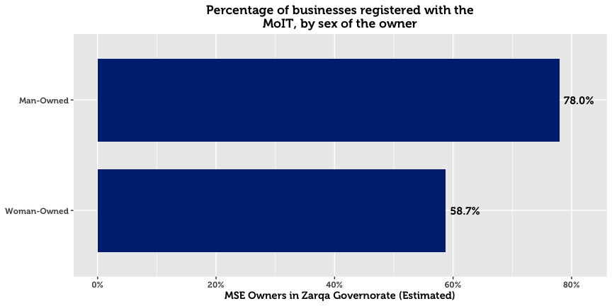

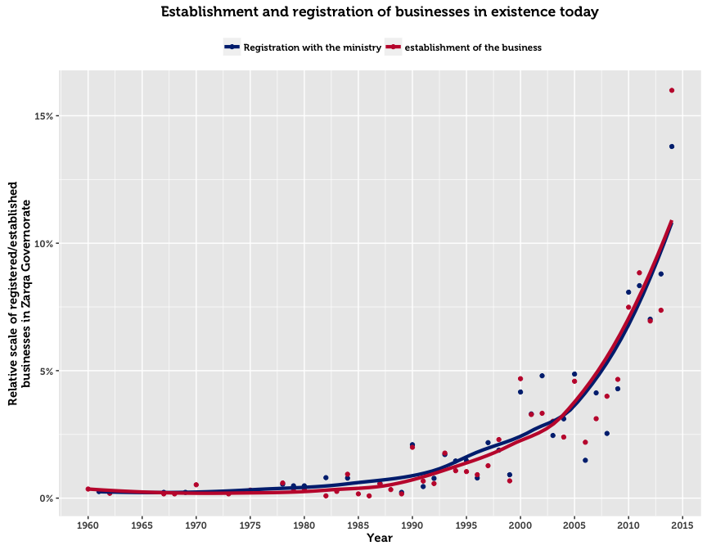

The above chart plots the frequency of business establishments and registrations by year. Almost all registered businesses were established and registered in the same year. The upward trend in registrations over time is explained by three factors: (1) growth in the population of Jordan, (2) initiatives by the government to increase awareness and simplify the registration process, and (3) survival rates. The third reason implies that businesses that existed in the past but no longer operate become excluded from the sample. Such business may have gone out of business for financial reasons, or ceased to exist due to the passing of the owner.

For those who chose to register, three main reasons emerge. The first reason is that registration is that registration is legally compulsory for their type of business (cited by 47.3%). The second is that MSE owners fear fines or harassment by police and authorities (cited by 44.2%). The support available from the government once registered, availability of insurance or official protection, and access to finance were not considered to be important primary motivations for business registration.

On the flip side, the dominant explanation given by half of the unregistered MSEs in Zarqa is that they see no benefits from officially registering their business (33.4%). 43.5% of MSEs who did not register responded with the category “Other” when asked for a reason.

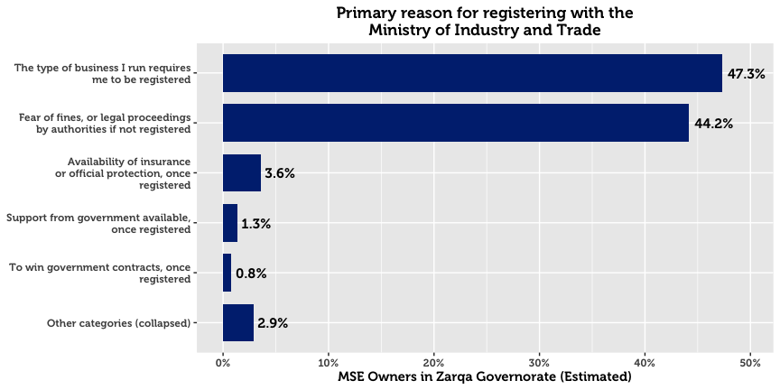

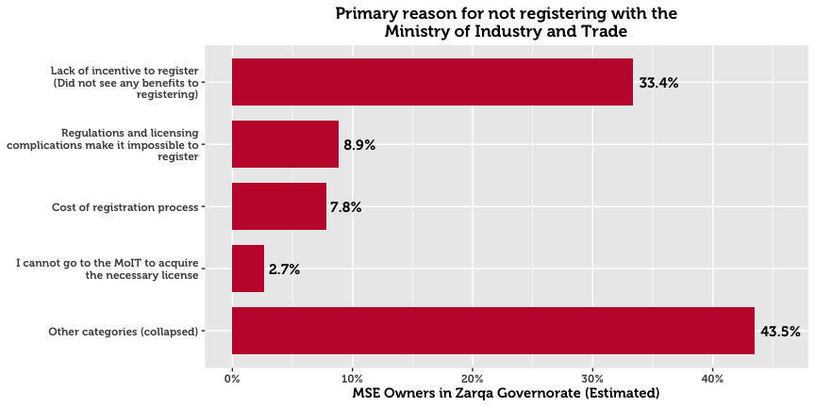

## Seasonal Business

An estimated 96.8% of MSEs operate all year round. Woman-owned businesses are 2.9 times as likely as man-owned businesses to be seasonal.

## Working Hours

52.5% of businesses owners work over the recommended 49 hours a week. This trend of long work hours is particularly pronounced in the Food Processing and Tourism sectors.

## Location of Conducting Business

In Zarqa, the majority of business is conducted from commercial location (95.0%). This is more pronounced for men than women, as men are 1.2 times as likely to operate out of a fixed location out of the home.

In stark comparison, 2.8% of MSEs are home-based[7]. Gender differences on this dimension are high: 16.1% of female-owned business operate from their home, compared to 1.4% for man-owned businesses. Home-based businesses are most commonly found in the business of Electrical/plumbing, manufacturing of wearing apparel, or building. Only 0.9% of all businesses are run at changing place public spaces (such as streets and parks). Those who participate in these changing locations are almost exclusively male.

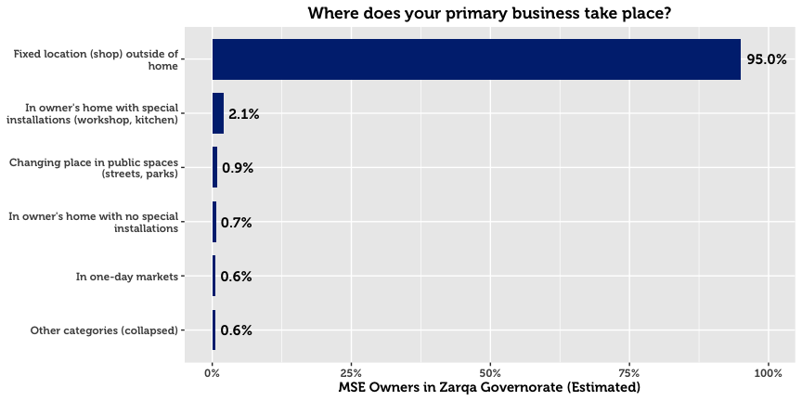

## Business Motivation

The main motivation for starting an MSE is primarily a result of the desire to become a business leader. 54.0% of MSEs state that this the main reason they started their business. The second most popular reason is to generate income for the family. This response was more common among women (35.0% of women cited this as their primary motivation, compared to 14.6% of men. This suggests that women may be under greater pressure to provide additional income to support family. The third most frequent reason is an interest in the line of industry.

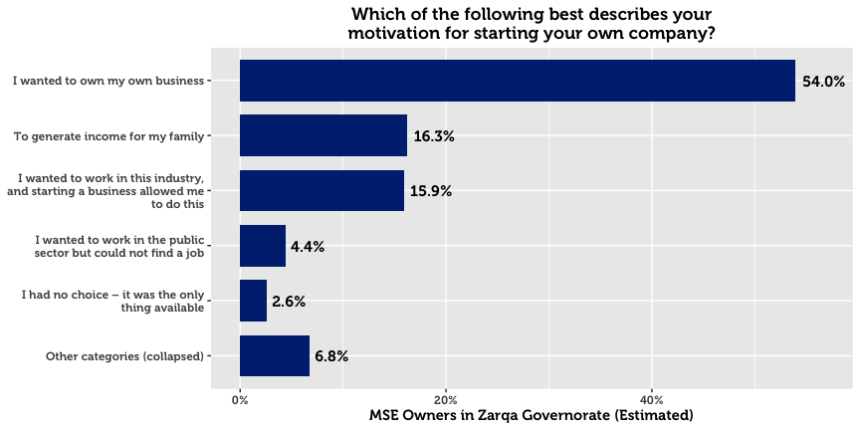

## Conducting Other Business

A low number of MSE owners have more than one business or income-generating project (12.4%). Men are 1.2 times as likely as women to have another business.

## Legal Ownership of Business

78.4% of businesses in Zarqa are self-owned. For the others, 6.8% are owned by a male family member, and 5.8% by a male non-family member.

## Form of Incorporation

The majority of MSE owners who are formally registered exist as sole proprietorships (90.0%). Others are typically either Limited Liability Companies (4.3%) or General Partnerships (2.5%). These last two categories are more common among companies that have employees. This is not surprising; given we would expect this to be the case with bigger enterprises.

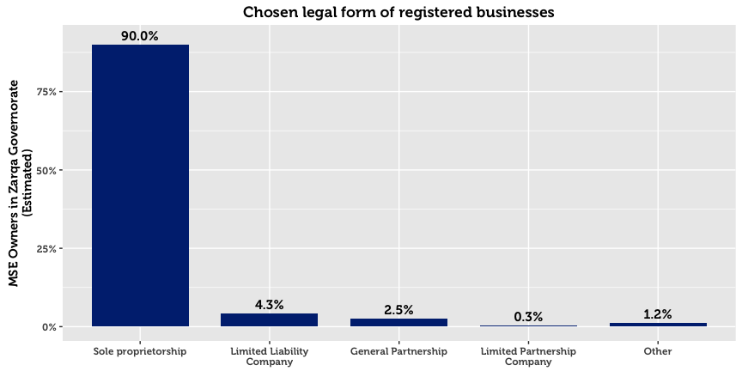

## Licensing

MSEs are by and large licensed with their municipalities. However, there exists a small subset that are registered but not licensed (0.9%), and a subset that are licensed but unregistered (1.6%). This may point to either a) misunderstanding of the question on behalf of the respondent, b) an expired license from the municipality, or c) an informal or illicit acquisition of a license from the municipality. As one might expect, home-based businesses and single-person businesses have far higher chances of being unlicensed.

The three primary reasons cited by MSE owners for not being licensed are that they see no benefits to doing so (19.0%), that they do not want to pay licensing fees (11.3%), and that it is not required for their business (9.2%). Nearly half of the respondents cited “other reasons,” perhaps due to reluctance to answer truthfully to a sensitive question.

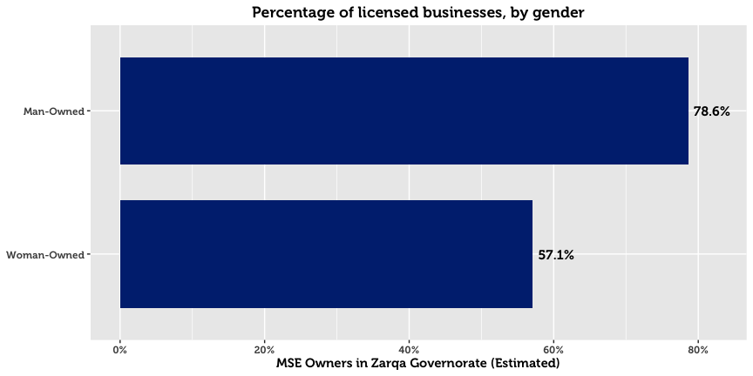

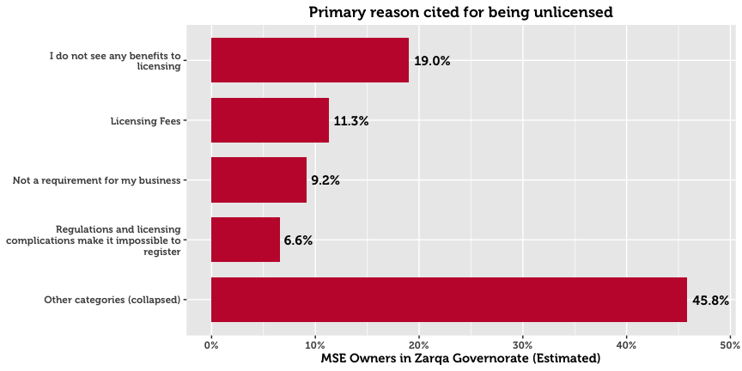

# Contracts

A large majority of surveyed enterprises never sign contracts: 86.7% of all MSEs. Only 6.7% report signing contracts either always or often. In an event of a dispute, almost no MSE owners opt to take legal proceedings. One in ten reports that they will resort to doing nothing. 76.5% will resort to informal meeting or family intervention.

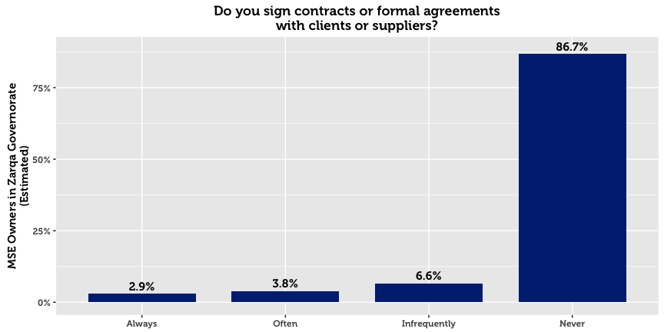

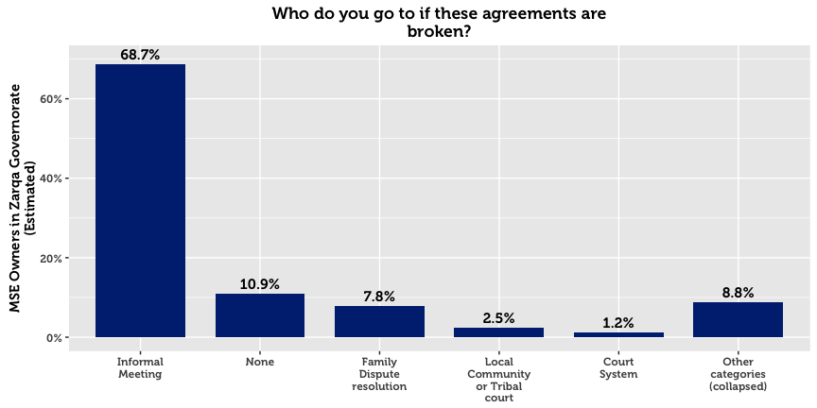

# Workforce

Just under half of Zarqa’s MSEs hire employees. The overwhelming majority of these enterprises employ less than three full-time workers across various sectors. Employment of women is rare, as only 7.3% of all MSEs in the governorate have female employees (12.5% for MSEs with employees).

37.4% of the MSEs with employees in Zarqa did not hire any new employees in the last year, and 30.9% hired exactly one employee. Only 6.2% of these enterprises report employing workers below the age of 18.

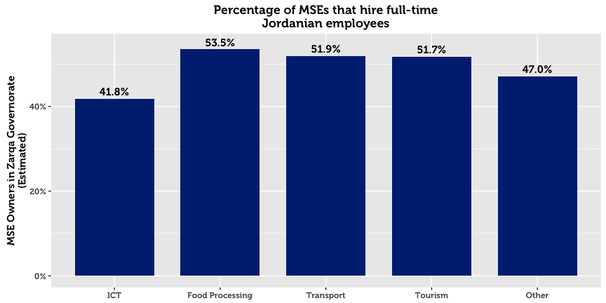

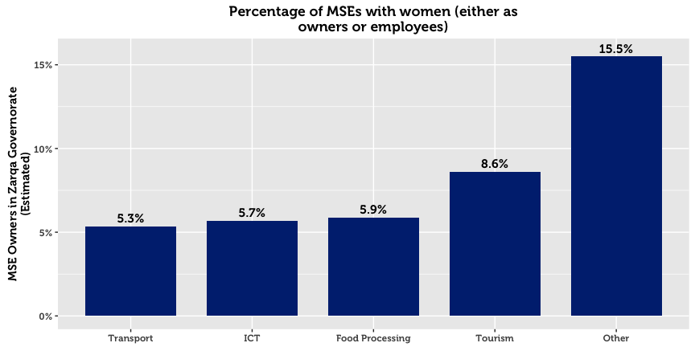

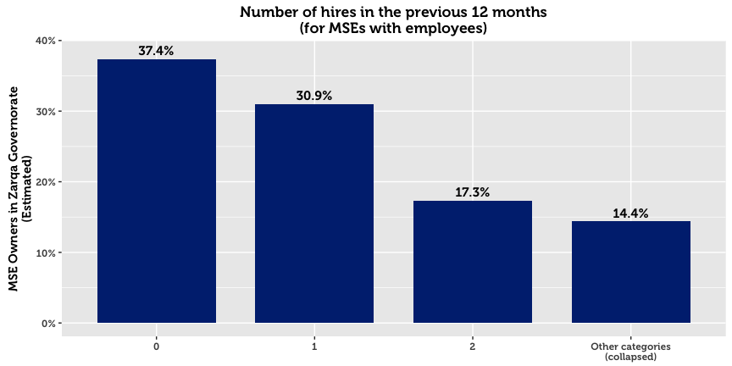

42.8% of enterprises hire between 1-3 workers. Of those that hire workers, 82.9% say that none left their business during the previous 12 months. Of those that experience talent loss, the major attributions are personal reasons, employees leaving to start their own business, salary demands, and unsuitable working hours.

|  |  |  |
| --- | --- | --- |
| **Primary Reason for Employee Loss (Zarqa)** |  | **All** |
|  |  | *N* = 1,307[8] |
| Hired by a competitor for a better wage |  | 28.0% |
| Personal reasons |  | 25.6% |
| Unsuitable working hours |  | 24.4% |
| The company could not afford a much higher salary |  | 6.1% |
| Employee did not envisage a career within the industry |  | 4.5% |
| Other reasons |  | 11.4% |

## Employee Training

Only 28.2% of MSEs with employees offer their workers in-house training. Those that do typically offered technical training or informal mentorship. External trainings for employees are less common at 18.7%.

|  |  |  |  |  |
| --- | --- | --- | --- | --- |
| **MSEs that Offer Employee Training* (Zarqa)** |  | **In-House** |  | **External** |
|  | 28.2%  *N* = 2,154 |  | 18.7%  *N* = 1,429 |
| Technical |  | 20.2% |  | 11.3% |
| Informal advice/mentorship |  | 19.7% |  | 10.7% |
| Marketing assistance/market information |  | 9.3% |  | 6.0% |
| Business Management training |  | 7.6% |  | 1.9% |
| Recordkeeping |  | 5.2% |  | 1.9% |
| Human resources/soft skills training |  | 4.4% |  | 1.3% |
| Other |  | 11.9% |  | 9.7% |
| *\* Domain of analysis comprises only of companies with employees (7,638 total)* | | | | |

## External Assistance

It is estimated that only 6.0% of MSEs in Amman receive technical assistance.[9] A very small proportion receive assistance[10] from a private company (2.7%), a business service provider (1.9%), a government program (1.7%), or from informal networks such as friends and family (1.1%).

# Firm Performance

66.6% of MSE owners report that they are either losing money or struggling to live comfortably. Only one third of surveyed enterprises maintain that their business allows them to live comfortably, and less than 1.0% claim that their company allow them to live well above their living costs.

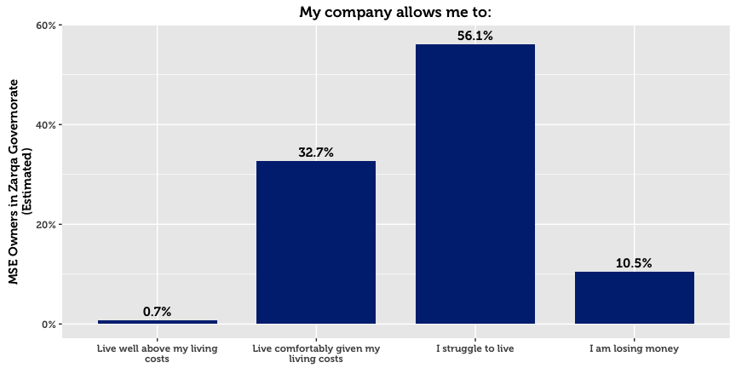

## Barriers to Economic Growth for MSEs

MSE owners were asked to state whether they agreed or disagreed that the following items represent barriers to the development their firms:

|  |  |  |  |  |  |
| --- | --- | --- | --- | --- | --- |
| **Barriers to Success (Zarqa)** |  | **All** |  | **By Sex** | |
|  |  | *N* = 15,733 |  | Men | Women |
| Low Demand |  | 67.8% |  | 68.5% | 61.0% |
| Low Purchasing Power |  | 53.3% |  | 53.7% | 49.2% |
| Lack of family support |  | 24.3% |  | 23.9% | 28.4% |
| Uncompetitive products |  | 22.0% |  | 21.7% | 25.0% |
| Lack of human resource options |  | 21.4% |  | 21.9% | 17.0% |
| Cannot compete with quality of the products? |  | 20.1% |  | 20.6% | 14.9% |
| Lack of financial support |  | 19.3% |  | 18.4% | 27.7% |
| Lack of appropriate suppliers |  | 17.2% |  | 15.8% | 30.5% |
| Lack of management skills |  | 15.3% |  | 15.7% | 11.4% |
| lack of market information about the markets |  | 13.4% |  | 13.1% | 16.0% |
| lack of proper marketing skills |  | 12.1% |  | 11.4% | 18.7% |
| Weak technical support or skills in this area |  | 11.9% |  | 12.0% | 11.4% |
| Unreliable transportation network |  | 10.0% |  | 10.5% | 4.9% |

The majority of firms believe that the major barriers are macro-economic in nature. Low purchasing power and low demand top the list of barriers to success. Despite the fact that most MSEs lack many formal processes and mechanisms such as a bank account or trainings, most do not perceive this a major gap or barrier. Similar to the other two northern governorates, fewer MSEs in Amman indicated that a lack of appropriate suppliers was a barrier to development compared to the governorates of the south (17.5%, compared to a combined average of 34.3% for the governorates of the south.)

## Financial Performance

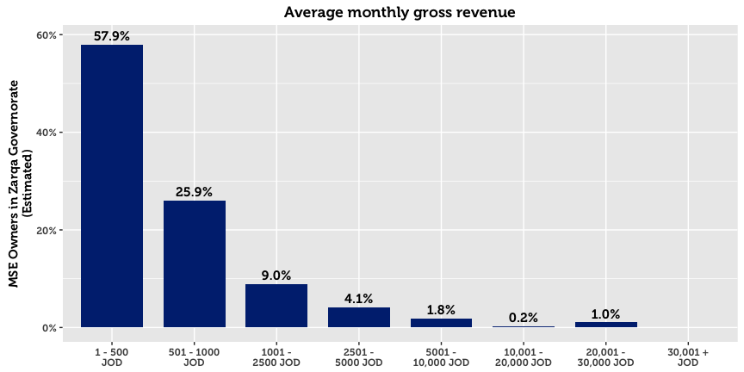

57.9% of MSEs in Zarqa report a monthly turnover of 500 JOD or less. However, 23.3% either refuse to disclose the exact amount, or do not know the amount. On average, women-owned MSEs, non-registered or home-based businesses, and single-person enterprises reported significantly lower gross revenue.

Profit is a more sensitive issue: Although 54.9% report finishing the previous month in the black, 9.8% refuse to disclose the exact amount, and 35.2% do not know. Nevertheless, of those who make profit and are willing to share this information, the median profit is 300 JOD. The median amount of savings per month in Zarqa is 300 JOD.

|  |  |  |
| --- | --- | --- |
| 7.1%  Of MSES in Zarqa make  monthly savings |  | 76.6%  Of MSEs in Zarqa make no  monthly savings |

# Access to Finance

Four in five micro and small enterprises in Zarqa generate enough money to sustain themselves without outside financing. Although many MSE owners struggle to live comfortably, as many as one in three say that they do not need a loan. Accordingly, financial institutions play a minor role in the economic development of MSEs, evidenced by the fact that only 5.9% of MSEs have applied for credit. In Zarqa, the most frequent reason is that the owner did not need to take out a loan (34.7% cited this as the main reason). Being in the Middle East, religious reasons also matter. Although the rise of Islamic Banking products makes this explanation less tenable, 32.7% of MSE owners cite religious prohibition as the main reason for not taking a loan.

The survey data suggests that MSE owners do not interact much with providers of credit, or even know about money markets. This is likely in view of the fact that most loan applications get approved (81.6% reported approval), that 17.9% believe that they only have one source of credit to their disposition, and that only 13.0% of MSEs have bank accounts. Of those who do not have accounts, 38.8% explain that they do not need one as their business requires working in cash, and 18.2% that low sales volumes do not justify having one.

Approved loans are typically used for business purposes, primarily to improve or upgrade products (37.5%), to buy more resources (materials or goods) (24.6%), to add new products or business activities (21.4%), or for the expansion or purchase of property (7.8%).

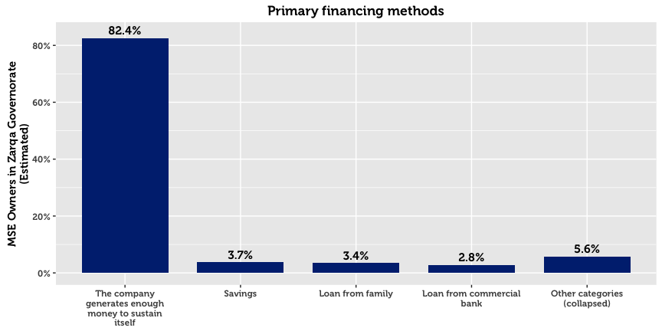

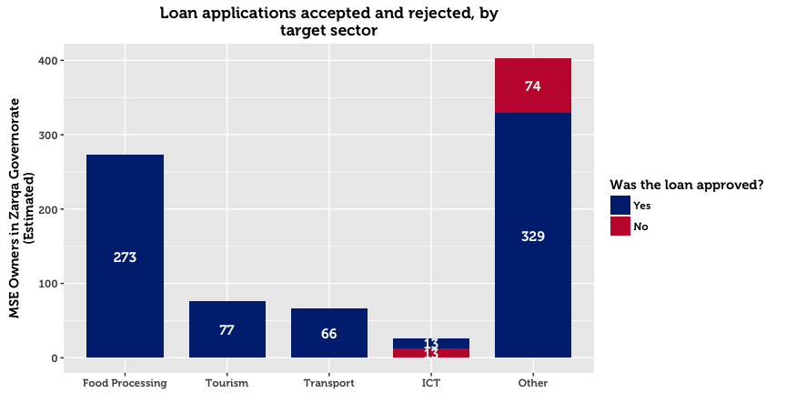

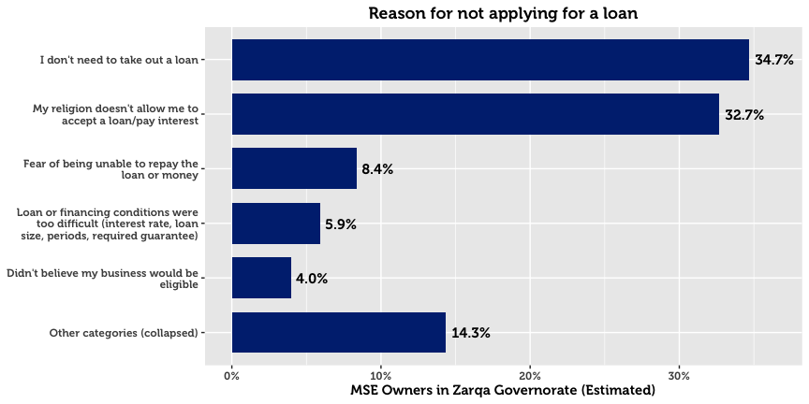

Of those who receive a loan, 43.3% receive it from a micro-finance institution, and 29.0% from a bank. Other sources for credit include private money lenders (10.7%), international donor (or donor-funded) projects (9.9%), and government programs (4.1%). When asked about the primary reasons for choosing a specific institution, 44.9% cite that their institution of choice offers the best financial prospects. 24.9% cite that they chose a particular provider because they are easy to understand and follow simple procedures.

Men and women differ greatly in the amount of money requested in loan applications. Whereas men request an average of 3,264 JOD, women MSE owners are far more conservative at 500 JOD. These differences may be confounded by the fact that the sex of the business owner is strongly associated with the subsector and location of the business.

# Systems, Processes and Networks

Online and offline use of computers within MSEs is limited, at 16.0% of firms. Smart phones and ordinary mobiles are used by 30.7% and 67.4% respectively. Over a quarter of MSEs in Zarqa use vehicles (27.8%), however this is significantly more common in man-owned than woman-owned businesses.

|  |  |  |  |  |  |
| --- | --- | --- | --- | --- | --- |
| **Resource Use (Zarqa)** |  | **All** |  | **By Sex** | |
|  |  | *N* = 15,733 |  | Men | Women |
| Mobile Phone |  | 67.4% |  | 68.6% | 56.6% |
| Smart Phone |  | 30.7% |  | 30.4% | 33.2% |
| Vehicle |  | 27.8% |  | 28.9% | 17.7% |
| Computer (with internet) |  | 11.5% |  | 11.0% | 16.2% |
| Computer (without internet) |  | 10.7% |  | 9.8% | 19.5% |
| Public internet location |  | 5.8% |  | 5.6% | 8.3% |
| Social media (work or personal) |  | 5.8% |  | 5.3% | 10.6% |
| Email (work) |  | 4.7% |  | 3.9% | 12.2% |

## Corruption

With respect to bribery, four fifths of enterprises report that they have rarely or never been asked for an informal payment.

## 

## Financial Planning

76.4% of MSEs in Zarqa keep records of their finances manually. Only 3.3% keep digital records of their books, and 20.3% do not keep records at all. As one might expect, this is particularly the case for unregistered businesses. Less than half — 38.9% — compare their business performance against financial goals.

## Memberships & Access to Networks

For the most part, MSEs are not part of associations. With the exception of the Chambers of Commerce and Industry, no association garners more than 5.0% of MSEs in the governorate. These categories included professional or trade associations (4.6%), cooperatives (2.0%), NGOs (0.9%), youth groups (0.8%), informal savings or loan groups (0.6%), wards or village committees (0.5%), women’s groups (0.3%), or micro-finance groups (0.2%).

Despite the fact that few participate in formal networks, 49.4% maintain they can get a meeting with the Mayor.

|  |  |  |  |  |  |
| --- | --- | --- | --- | --- | --- |
| **Memberships (Zarqa)** |  | **All** |  | **By Sex of the Owner** | |
|  |  | *N* = 3,640[11] |  | Men | Women |
| Chamber of Commerce |  | 16.7% |  | 17.5% | 8.3% |
| Chamber of Industry |  | 13.9% |  | 14.6% | 6.6% |
| Formal trade, business, or professional association |  | 4.6% |  | 4.0% | 10.5% |
| Cooperative |  | 2.0% |  | 2.2% | 0.0% |
| NGO |  | 0.9% |  | 1.0% | 0.0% |
| Youth group |  | 0.8% |  | 0.9% | 0.0% |
| Informal savings or loan group |  | 0.6% |  | 0.7% | 0.0% |
| Ward or village committee |  | 0.5% |  | 0.5% | 0.0% |
| Women’s group |  | 0.3% |  | 0.3% | 0.0% |
| Micro-finance group |  | 0.2% |  | 0.2% | 0.0% |

# Policy and Regulations

30.4% of MSE owners in Zarqa believe that they have access to policy and regulations to a large extent. 35.5% believe they have access to some extent, and 26.6% believe they have access to a little extent. 7.5% report not having any access to policy and regulations. As ‘digital literacy’ is relatively low, two thirds resort to traditional sources of information. In particular, MSE owners go to their municipality, friends and family, or lawyer for information.

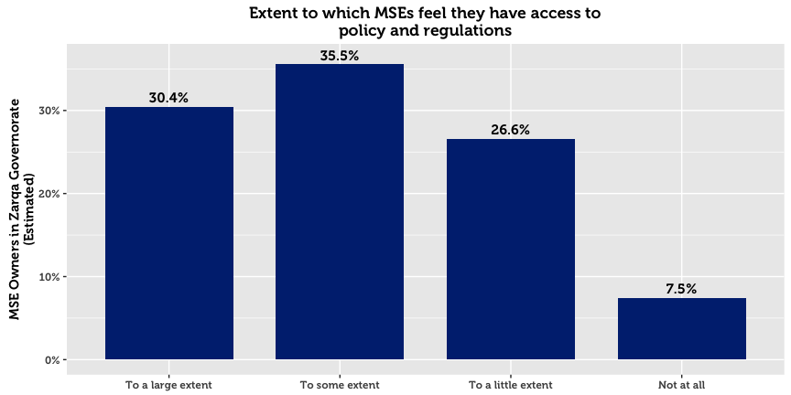

|  |  |  |  |  |  |
| --- | --- | --- | --- | --- | --- |
| **Policy Sources (Zarqa)** |  | **All** |  | **By Sex** | |
|  |  | *N* = 15,756 |  | Men | Women |
| Local municipality |  | 28.1% |  | 29.6% | 13.9% |
| Family and friends |  | 24.7% |  | 25.5% | 17.1% |
| No use for this information |  | 13.5% |  | 12.8% | 19.6% |
| Lawyer |  | 10.3% |  | 9.7% | 15.4% |
| Government website |  | 7.8% |  | 7.7% | 8.9% |
| Do not know |  | 7.5% |  | 6.8% | 13.5% |
| Local businesses and enterprises |  | 3.4% |  | 3.6% | 1.6% |
| Business support center |  | 1.2% |  | 1.1% | 1.6% |
| Refused to answer |  | 0.2% |  | 0.2% | 0.0% |
| Other |  | 3.4% |  | 2.9% | 8.2% |

1. In this paper, micro- and small-enterprises are categorized in accordance with USAID LENS’ definition. A business (formal or otherwise) having fewer than 10 full-time employees (excluding the owner) is classified as a microenterprise, whereas businesses with 10 to 49 full-time employees, are categorized as small.
2. Throughout this paper, the area of “Amman” refers to the geographic area of Amman governorate, excluding the Greater Amman Municipality (“GAM”) which was excluded from the study. The area of “Aqaba” refers to the Aqaba Governorate, excluding the Aqaba Special Economic Zone (“ASEZA”).
3. Although results are representative of MSEs within each geographic area, results cannot be disaggregated on a more granular geographic level without compromising on acceptable sampling error rates. This is due to the clustering design in the first phase.
4. This total represents an estimate for the total number of MSE-owners, without accounting for multiple ownership. The survey reveals that 12.1% of business owners in Zarqa have a second business. The total number of MSEs is therefore higher than the total number of MSE owners. Throughout this report, we relax this strict distinction and commonly use language such as “X% of MSEs…” when referring to data about MSE owners.
5. In this report, “Population Estimate” means the absolute number of MSE owners in Zarqa, estimated using inclusion probabilities from the random sample. This statistical definition of “population” is not the same as the general understanding of the word in everyday language, which refers to the total number of people living within the boundaries of a nation state. Although many statistical publications use or when referring to these estimates, in this report we use the more intuitive notation *N* to denote population estimates, and *n* to denote unweighted sample counts.
6. Four sectors are examined throughout this report: Tourism, ICT, Transport, and Food Processing. These groupings are created on the basis ISIC-4 classifications collected in the survey, and are the primary data to reflect the four target sectors used for interventions in the LENS project.
7. In this report, a home-based business is any enterprise or income-generating project that operates from the owner’s home. As a result, this definition does not include MSEs operating in the homes of clients (maids, personal care, etc.)
8. 1,307 out of 15,733 businesses in Zarqa Governorate lost employees in the last 12 months.
9. Due to an error in the tablet software used for interviews, questions concerning technical assistance were only posed to MSE owners with employees.
10. Understood as financial or resource contributions from an international or local agency.
11. 3,640 businesses are in at least one business association